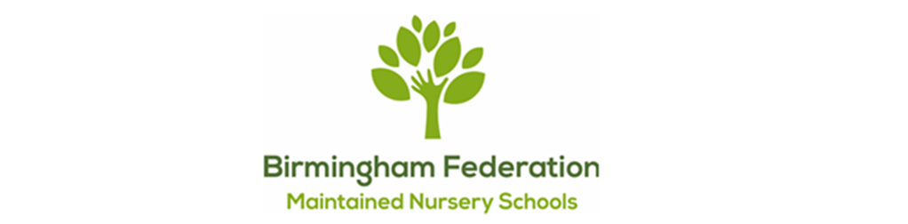

Adderley Nursery School | Allens Croft Nursery School | Gracelands Nursery School
Highfield Nursery School | Jakeman Nursery School | Lillian de Lissa Nursery School
Newtown Nursery School | Shenley Fields Nursery School | St Thomas Centre Nursery School

LETTINGS POLICY

Full Governing Body Approved: 09 Feb 2026
Date for renewal: Spring 2028

Chair of Governors: Sean Delaney

Lettings

Lettings conditions

The letting of the premises is welcomed, subject to the following conditions:
- Use of the premises for school functions will take priority over lettings.
- The Governing Body of Birmingham Federation of Maintained Nursery Schools will set charges for lettings guided by these principles:
- Lettings to bona fide community groups will be charged at cost, to cover caretaking, energy, wear & tear and administration;
- Where a letting is subsidised by a service of Birmingham City Council, that service will determine the proportion of the letting charge to be paid direct by the Hirer;
- Where the school is used as a polling station, the relevant authority will be charged the actual additional costs incurred by the school;
- Lettings to all other hirers will be charged at cost plus a profit margin determined by the Governing Body.

- The school reserves the right to request a returnable deposit, which will be returned to the hirer in full within 14 days of the period of hire subject to the hired premises being left to the required standard.
- The school will retain income derived from lettings. Costs of lettings to the school will be met from this income.
- The school premises will not be let to individuals or organisations if there is reason to believe that the name of the school will be brought into disrepute.
- The school premises will not be let for functions where a Public Entertainment, Intoxicants or other Licences are required.
- Decisions whether to permit lettings will be made by the Head Teacher. If the Headteacher believes a letting should not be permitted, they will report the reasons to the Governing Body.
- Hirers of the school premises will be expected to conform to the relevant Health & Safety regulations.
- Hirers shall be present at all times during the period of hire.
- All hirers must carry sufficient public liability insurance to satisfy Birmingham City Council requirements and which is in force during the period(s) of hire.
- Hirers shall give special attention to the behaviour of those in attendance during the period(s) of hire and to the interests of residents and the school’s community so that they are not disturbed or caused any inconvenience.
- Hirers shall not assign or sublet the permission given to use the school premises.
- The school reserve the right at any time to refuse or cancel any function without assigning a reason and will agree in such circumstances, to fully reimburse any monies received from the hirer.
- In deciding whether to allow any group or organisation to make use of its buildings, facilities and property, the Birmingham Federation of Maintained Nursery Schools will take into account the views, policies and objectives of that group or organisation and may refuse on the grounds that these are incompatible with the policies and objectives of the school. In particular, access will be refused if it appears likely that the proposed activity would promote extremist ideological, political or religious beliefs.
- No person may use the facilities of the Birmingham Federation of Maintained Nursery Schools to express or promote extremist ideological, religious or political views.
- No person may use the facilities of the Birmingham Federation of Maintained Nursery Schools to express or promote discriminatory views in relation to the protected characteristics listed in the Equality Act 2010.
- The Birmingham Federation of Maintained Nursery Schools will not allow the use of its facilities by any group or organisation that is proscribed by HM Government.
This policy runs in conjunction with our ‘No Platform for Extremism’ Policy and ‘The Prevent Duty’

